Mainframe Calculator
Category: Misc (Web / Scripting) | Difficulty: Medium

Description
The RoudyCon mainframe still does payroll, but its display died years ago. Jobs come off the line printer as QR codes, and the night-shift operators got into the habit of wrapping each job in *some* encoding first. Nobody remembers which. It may not even be the same one twice.
It has 33 jobs for you. It is not a patient machine. It is not a fast one either.
http://<host>:8080/
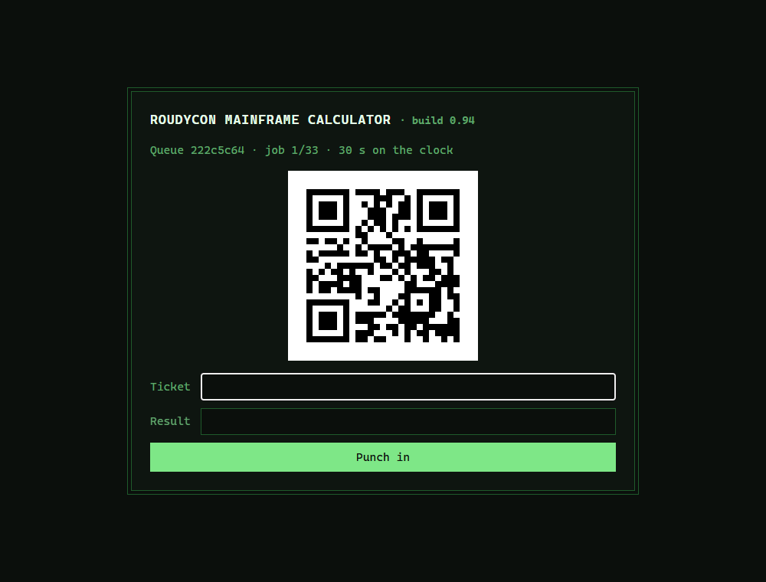
A single job: a QR code and a punch-in form, on the clock

Files
One hosted Docker container, built from challenge/. From that folder:
cd challenge
docker compose up --build -d # serves http://localhost:8080
Plain HTML forms, no JavaScript — it works from curl, a phone, or a script. The flag and timing knobs (FLAG, FIRST_TIMEOUT, ROUND_TIMEOUT, TOO_FAST) are set in challenge/docker-compose.yml. The app is a stateless Flask service (challenge/server/server.py); round state rides in a signed hidden token, so there's no database. Reference solver and writeups are in organizer/: solution/solve.py (needs Pillow + a QR decoder), README.md, solution.md.

Hint(s)
- Round one is plain base64. After that it's a different encoding each time — try the usual suspects (base64, base32, hex, rot47, single-byte XOR) until one reads like a job.
- Too many jobs to do by hand, but tear through them and the machine decides you cheated. Add a small pause between jobs.
- Clear the queue at a steady pace and the mainframe just prints the flag — no final step to fight. Go too fast and it won't.

Walkthrough
The challenge name *is* the walkthrough: scan a QR code, decode whatever the night shift wrapped it in, calculate the sum inside, and repeat — at a believable pace — until the queue runs dry.
- Recon. / explains the setup; /start opens a queue and renders a job: a status line, one QR code (inline PNG), and a form posting ticket, result, and a signed hidden token to /answer. There's no session — the token carries the round number, queue id, deadlines, and a keyed commitment to the expected answer, and travels with every request.
- Decode the layers. Pull the base64 PNG from the <img>, decode the QR with any library. What comes back is a *job* under one more wrapper: round 1 is always base64, every round after picks one of base64 / base32 / hex / rot47 / single-byte-XOR at random. You don't have to recognize which — a real job always matches #<digits>: <arithmetic>, so try all five decoders (brute-forcing the 255 XOR keys) and keep the one that matches.
- Do the sum. The expression is integer + - * / (divisions always come out even); parse it with ast rather than eval(). Each answer is 0–255 — and is actually flag_char XOR pad_byte, so the values you punch in never spell anything. The ticket (random, only inside the QR) stops anyone brute-forcing /answer blindly.
- The pacing trap. POST /answer before the deadline (30 s on job 1, 5 s after) advances to the next job. But clear the whole run in under 10 s and the operator decides nobody reads a printer that fast — you get a music video, no flag. Too slow and you miss a deadline. The window that works is ~0.3 s to 5 s per job; ~0.35 s/job is comfortable. Firing as fast as the network allows hits the "too fast" ending:
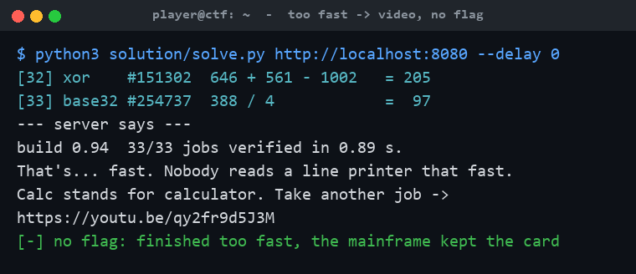
Going too fast: "calc stands for calculator", no flag
- Clear the queue at pace → flag. You never un-mask anything yourself: finish all 33 jobs at a human-ish pace and the server runs your masked answers back through the per-queue pad and prints the flag on the finish page:
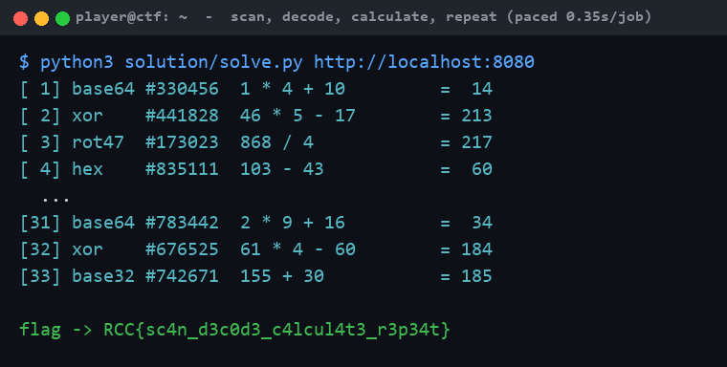
The paced solver clears all 33 jobs and the mainframe prints the flag

Flag
RCC{sc4n_d3c0d3_c4lcul4t3_r3p34t}

